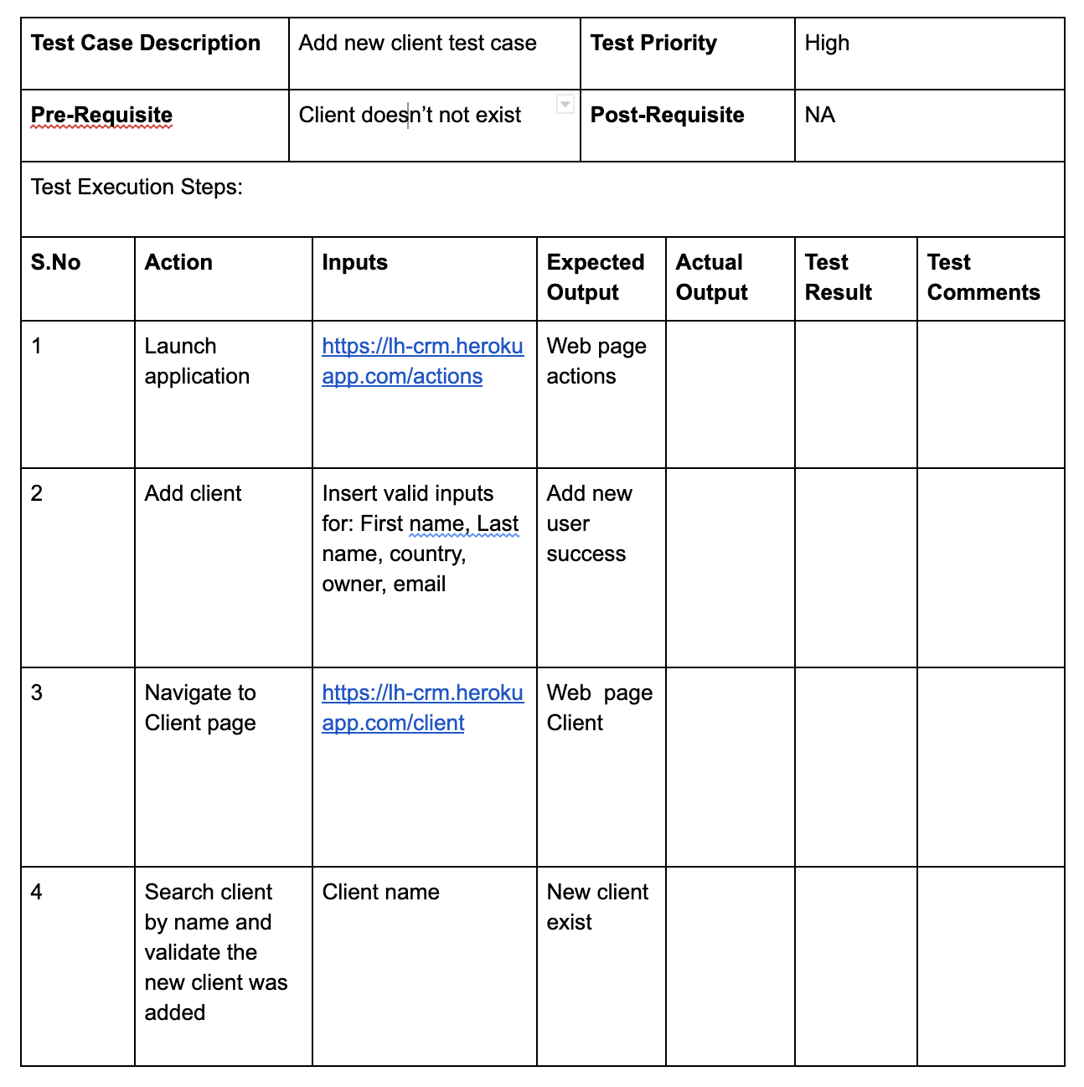

|  |  |  |  |  |  |  |  |  |
| --- | --- | --- | --- | --- | --- | --- | --- | --- |
| **Test Case Description** | | Update Client Test Case | | | **Test Priority** | | High | |
| **Pre-Requisite** | | A client that exists in the system. | | | **Post-Requisite** | | NA | |
| Test Execution Steps: | | | | | | | | |
| **S.No** | **Action** | | **Inputs** | **Expected Output** | | **Actual Output** | **Test Result** | **Test Comments** |
| 1 | Launch application | | <https://lh-crm.herokuapp.com/actions> | Web page Actions. | |  |  |  |
| 2 | Update Client | | Insert Valid Value for Client, Transfer Ownership to, email type, click to declare as Sold. | Update Client Success. | |  |  | לשלוח רק 2 פרמטרים  Client , transfer |
| 3 | Verify that Update Success. | |  | Update Successful pop up Message Appears. | |  |  |  |

|  |  |  |  |  |  |  |  |  |
| --- | --- | --- | --- | --- | --- | --- | --- | --- |
| **Test Case Description** | | Update Client & Check Test Case | | | **Test Priority** | | High | |
| **Pre-Requisite** | | A client that exists in the system. | | | **Post-Requisite** | | NA | |
| Test Execution Steps: | | | | | | | | |
| **S.No** | **Action** | | **Inputs** | **Expected Output** | | **Actual Output** | **Test Result** | **Test Comments** |
| 1 | Launch application | | <https://lh-crm.herokuapp.com/actions> | Web page Actions. | |  |  |  |
| 2 | Update Client | | Insert Valid Value for Client, Transfer Ownership to, email type, click to declare as Sold. | Update Client Success. | |  |  |  |
| 3 | Verify that Update Success. | |  | Update Successful pop up Message Appears. | |  |  |  |
| 4 | Navigate to Client Page | | <https://lh-crm.herokuapp.com/client> | Web Page Client | |  |  |  |
| 5 | Search Client by Name & Validate that the Parameters was Updates. | | Client Name | Client parametersUpdate. | |  |  |  |

|  |  |  |  |  |  |  |  |  |
| --- | --- | --- | --- | --- | --- | --- | --- | --- |
| **Test Case Description** | | Update Client - Negative Test Case | | | **Test Priority** | | High | |
| **Pre-Requisite** | | A client that exists in the system. | | | **Post-Requisite** | | NA | |
| Test Execution Steps: | | | | | | | | |
| **S.No** | **Action** | | **Inputs** | **Expected Output** | | **Actual Output** | **Test Result** | **Test Comments** |
| 1 | Launch application | | <https://lh-crm.herokuapp.com/actions> | Web page Actions. | |  |  | Same function as test 2 |
| 2 | Update Client | | Insert Invalid Value for Client, Transfer Ownership to, email type, click to declare as Sold. | Update Client Fail. | |  |  |  |
| 3 | Verify that Update Fail. | | Some details are missing. | Fail pop up Message Appears. | |  |  |  |